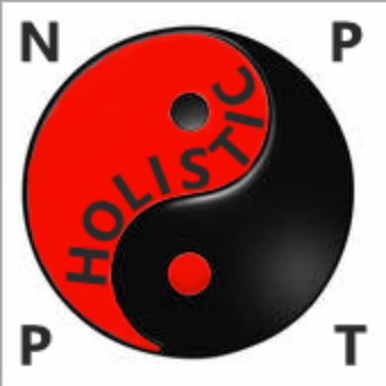
MMA STREET DEFENCE MARTIAL ARTS CLASS
- Want to improve, health and fitness along with overall state of mind and wellbeing?
- Want to gain confidence, lose weight or feel more centred?
- Want to learn how to defend yourself effectively and realistically in a safe and friendly environment?
- Want especially tailored nutritional and dietary advice?
If you answered yes to any of the above, whether you want to learn self defence, tai chi, or just wish to improve your health and fitness and sense of wellbeing. Practising Tai Chi can help:
- Personalised training and/or nutrition plans
- One-to-one fitness sessions, within a gym, outdoors or at your home
- One-to-one martial arts or self-defence sessions, within a gym, outdoors or at your home
- Group fitness, Tai Chi or martial arts & self defence sessions

TAI CHI AS A MARTIAL ART
Tai Chi Chu’an, is a form or sequence of chi gong movements seamlessy strung together and encompasses lots of different Martial arts moves, Tai Chi is also sometimes referred to as moving meditation or Chinese Yoga, and is a well known and ancient martial art. In fact, translated it actually means ‘the grand ultimate boxing’.It has also been shown to be very beneficial for health when practised correctly and has been practised in China for over 600 years, not only as a martial art but also as part of Daoism and a healthy lifestyle as I say. Below I’m teaching Tai Chi to a group for a Mayor’s Office DVD:
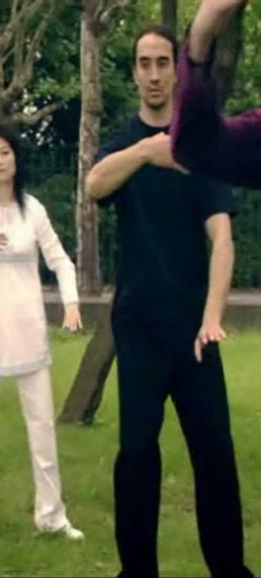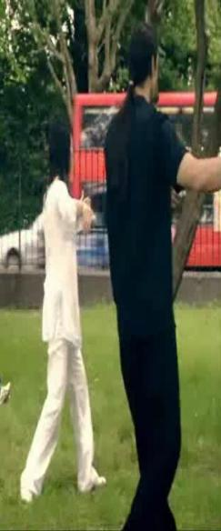
Our Mission Statement
Here at NP Holistic PT, we aim to improve the quality of people’s lives through a more holistic approach to lifestyle for health of body mind and spirit, and to deliver quality exercise, nutrition and self defence services, with integrity and effectiveness, promoting wellbeing and happiness to all we can.

GET IN TOUCH AND GET IN SHAPE
Contact me on the links below or see my contact details on the reverse of this flyer.
Read more about Tai Chi, Daoism* and meditation here on my website:
https://Tai-Chi36.webnode.co.uk/about-me
Read more about health, including my nutrition services and other health factors, on my website here:
https://health02.webnode.com/nutrition
I also have a Facebook page, which can be found here:
https://fb.me/NathanPHolisticPT
I have also set up a Twitter account, which can be found here:
https://twitter.com/NPHolisticPT
And I also have a Telegram group set up, where you can find out more and contact me directly:
https://t.me/PersonalTrainerLondon
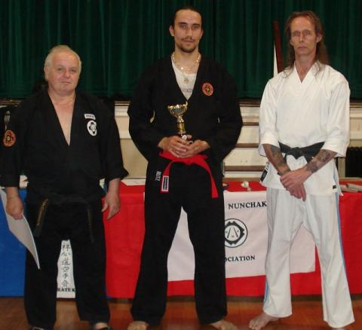
*Tai Chi is great for health and longevity for people of all ages and is part of Daoism which, although it is classed as a religion, is basically a healthy, holistic way of life and originated in China a few hundred years ago. See link at top of this section for more information
Contact Nathan for lessons:
07782174669
NathanShowreel@gmail.com
Location: Sydenham, SE26
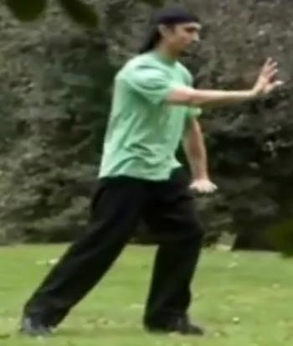
About The Teacher
Nathan is a Personal Trainer (YMCA Level 3) nutritionist, (LOCN level 3) and has practised various styles of Martial arts for over 25 years (more if counting childhood too) and also holds advanced belts in Krav Maga and Nunchaku-Do for instance. He has practised Yang style Tai Chi for over 20 years and completed a Tai Chi Instructor Seminar in 2009 for JDIATCC UK.
In that 20 years he has had 3 Tai Chi teachers and often assisted teaching for two of them, he has worked as a Tai Chi choreographer for The Daily Mail, The Mayor‘s Office, and can even be seen performing Tai Chi on the TV series M.I. High (photo above). He also earned a trophy in 2010 for British nunchaku combat champion (despite a last minute entry),

